Hkkjr ekSle foKku foHkkx |  | India Meteorological Department
Hkkjr ekSle lkjka’k |  | DAILY WEATHER SUMMARY
Monday, 24th January 2022 (4th Magha 1943 Saka)
Summary of observations recorded at 0830 hours IST: The western disturbance as a cyclonic circulation over Punjab and neighbourhood between 1.5 and 3.1 km above m.s.l. persisted. However, the trough aloft in mid and upper tropospheric westerlies with its axis at 5.8 km above m. s. l. ran roughly along Long.75°E to the north of Lat.32°N. Above systems are likely to move east-northeastward.A cyclonic circulation lay over Jharkhand and neighbourhood which extended upto 1.5 km above m. s. l. A trough ran from the cyclonic circulation over Punjab to the cyclonic circulation over Jharkhand and neighbourhood at 1.5 km above m. s. l. A cyclonic circulation lay over north interior Karnataka and neighbourhood and extended upto 1.5 km above m. s. l. The associated cyclonic circulation over Haryana and neighbourhood became less marked. The eastwest trough from the cyclonic circulation over Haryana and neighbourhood to north Chhattisgarh became less marked. The northsouth trough from Bihar to north Odisha became less marked.
Night temperatures were markedly above normal (5.1 or more) at isolated places over east Madhya Pradesh, Bihar and Tamil Nadu, Puducherry and Karaikal; appreciably above normal (3.1°C to 5.0°C)at most places over Punjab, east Uttar Pradesh, Jharkhand; at many places over Uttarakhand, Chhattisgarh and coastal Andhra Pradesh; at a few places over Himachal Pradesh ,Gangetic West Bengal and at isolated places over Odisha; above normal (1.6°C to 3.0°C) at many places over Assam, Meghalaya and Rayalaseema; at a few places over Haryana, Chandigarh, Delhi and west Uttar Pradesh and at isolated places over Sub-Himalayan West Bengal, Sikkim, Telangana and Madhya Maharashtra. They were appreciably below normal (3.1°C to 5.0°C) at many places over Gujarat State; at isolated places over east Rajasthan, Konkan and Goa ; below normal (-1.6°C to-3.0°C) at most places over Andaman and Nicobar Islands; at many places over Marathwada; at a few places over west Rajasthan and east Madhya Pradesh ; at isolated places over Vidarbha, Kerala, Mahe and near normal over rest parts of the country. Today, the lowest minimum temperature of 4.0°C was reported at Sikar (West Rajasthan) over the plains of the country.
Yesterday, cold day to severe cold day conditions prevailed in some parts of Himachal Pradesh, west Madhya Pradesh, Haryana-Chandigarh and Uttarakhand. Cold day conditions in isolated pockets over east Madhya Pradesh, west Uttar Pradesh, Rajasthan and Jammu division.
Thunderstorm accompanied with lightning (from 0830 hours IST of yesterday to 0830 hours IST of today): at isolated places over Uttar Pradesh.
Fog observed (at 0830 hours IST of today): Dense to very Dense Fog in isolated pockets of Himachal Pradesh, Uttarakhand, Haryana, west Uttar Pradesh, Chhattisgarh, Madhya Maharashtra, Jharkhand, Assam and Meghalaya; Shallow to moderate fog in isolated pockets of east Uttar Pradesh and Odisha , Shallow fog in isolated pockets of Punjab, west Rajasthan, Delhi, Bihar, east Madhya Pradesh, Gangetic West Bengal and Tripura.
Visibility recorded (at 0830 hours IST of today)(500m or less): Agra-0; Mahabaleshwar-25; Kalpa, Shimla, Karnal, Mukteshwar, Aligarh, Ambikapur, Ranchi and Haflong-50 each; Pantnagar, Meerut, Kanpur, Nowgong and Chandbali-200 each; Amritsar, Ganganagar, Hissar, Delhi (Palam), Tehri, Lucknow, Varanasi, Khajuraho, Motihari, Daltonganj, Jamshedpur, Panagarh, Shanti Niketan and Aijal-500 each.

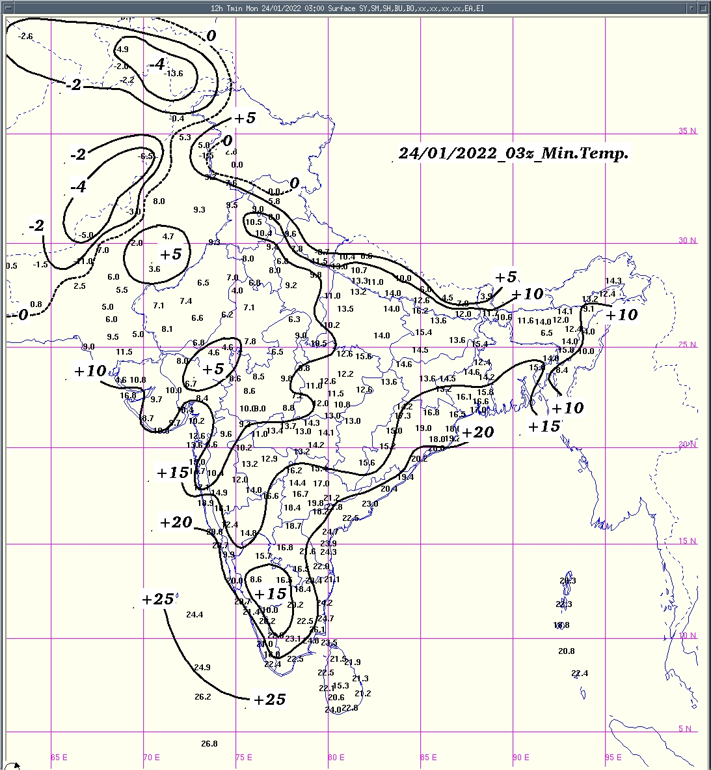 | 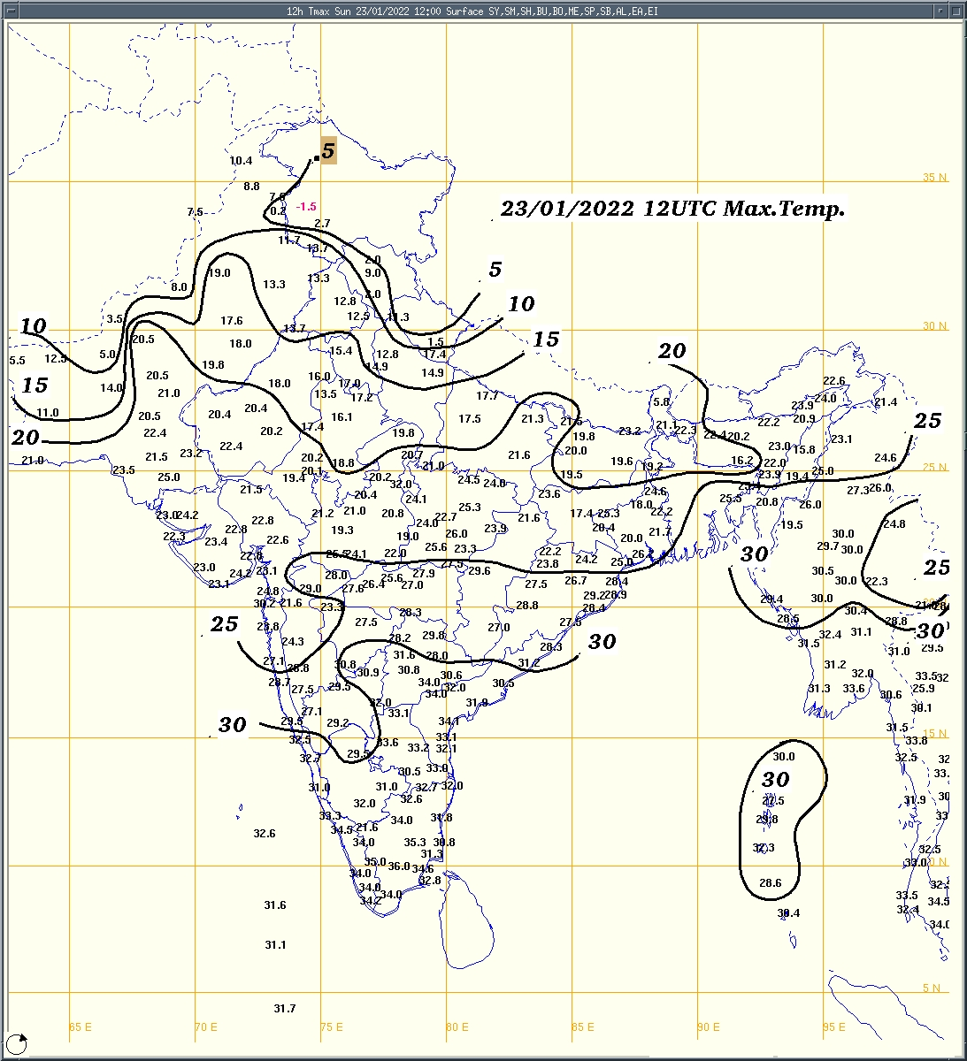 | 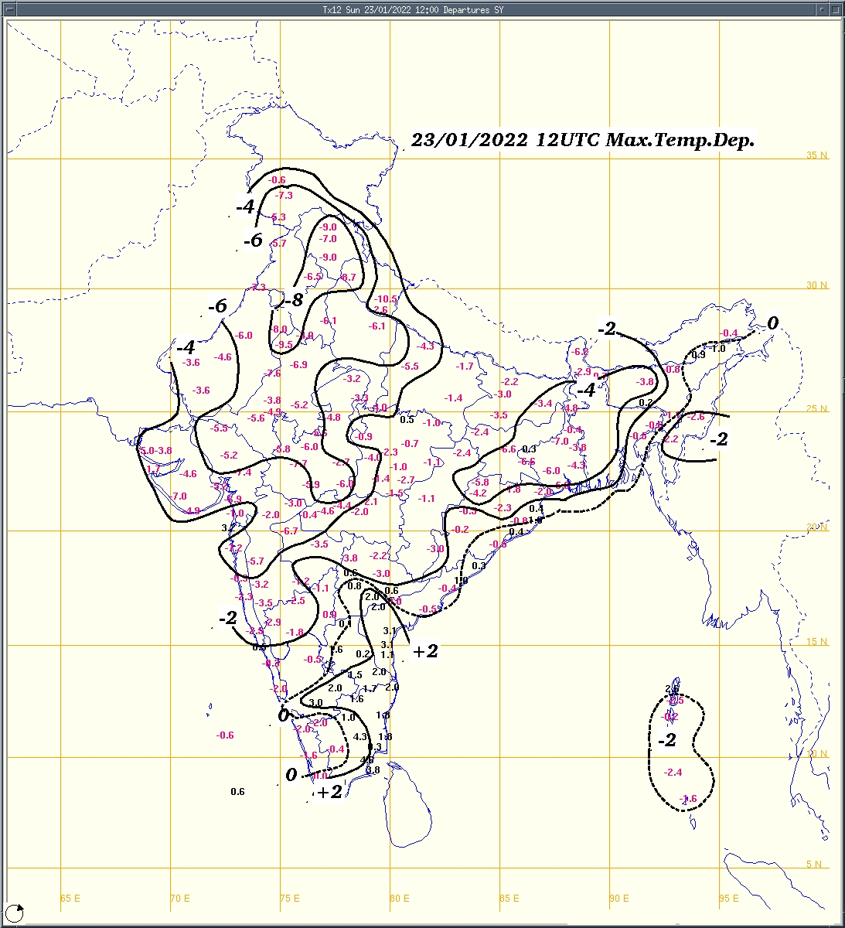
Fig.1a: Minimum temperature (⁰C) | Fig.2a: Maximum temperature (⁰C) | Fig.2b: Maximum temperature departure(⁰C)
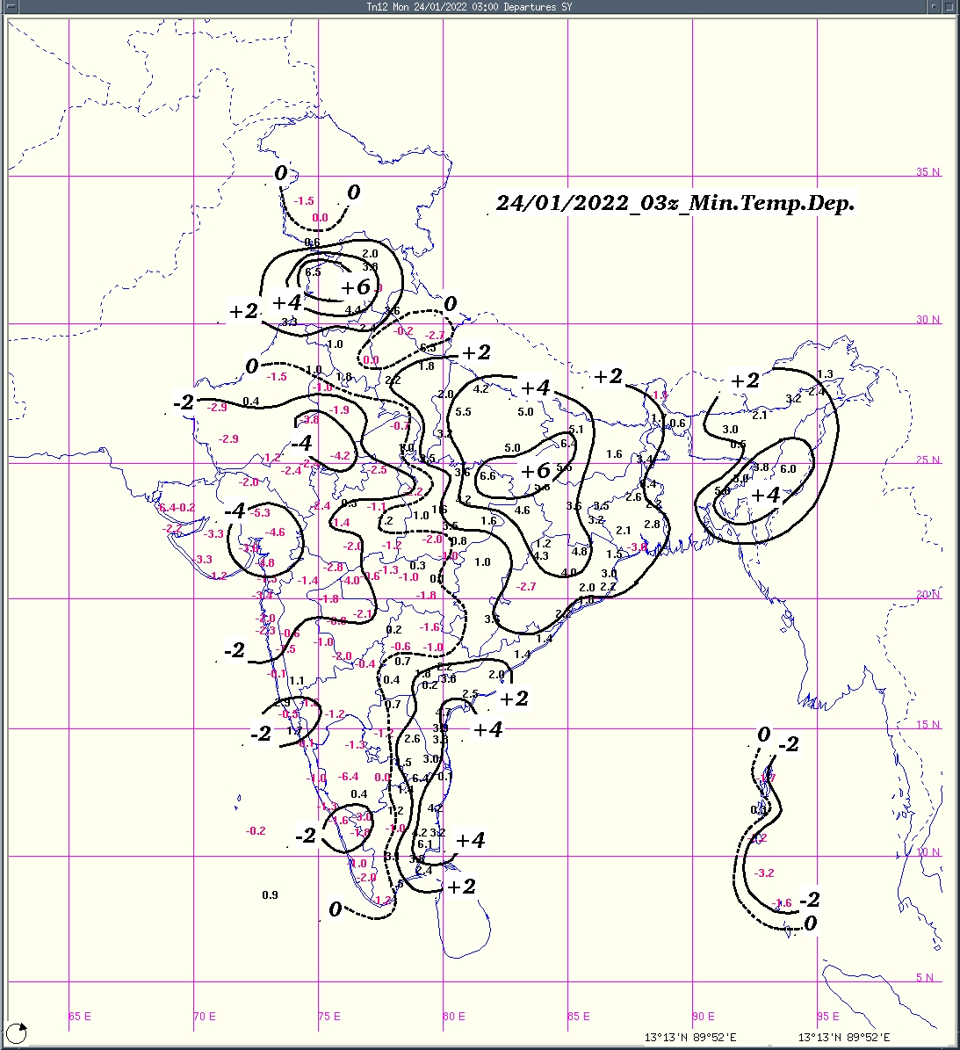  Fig.1b:Minimum temperature departure (⁰C) | 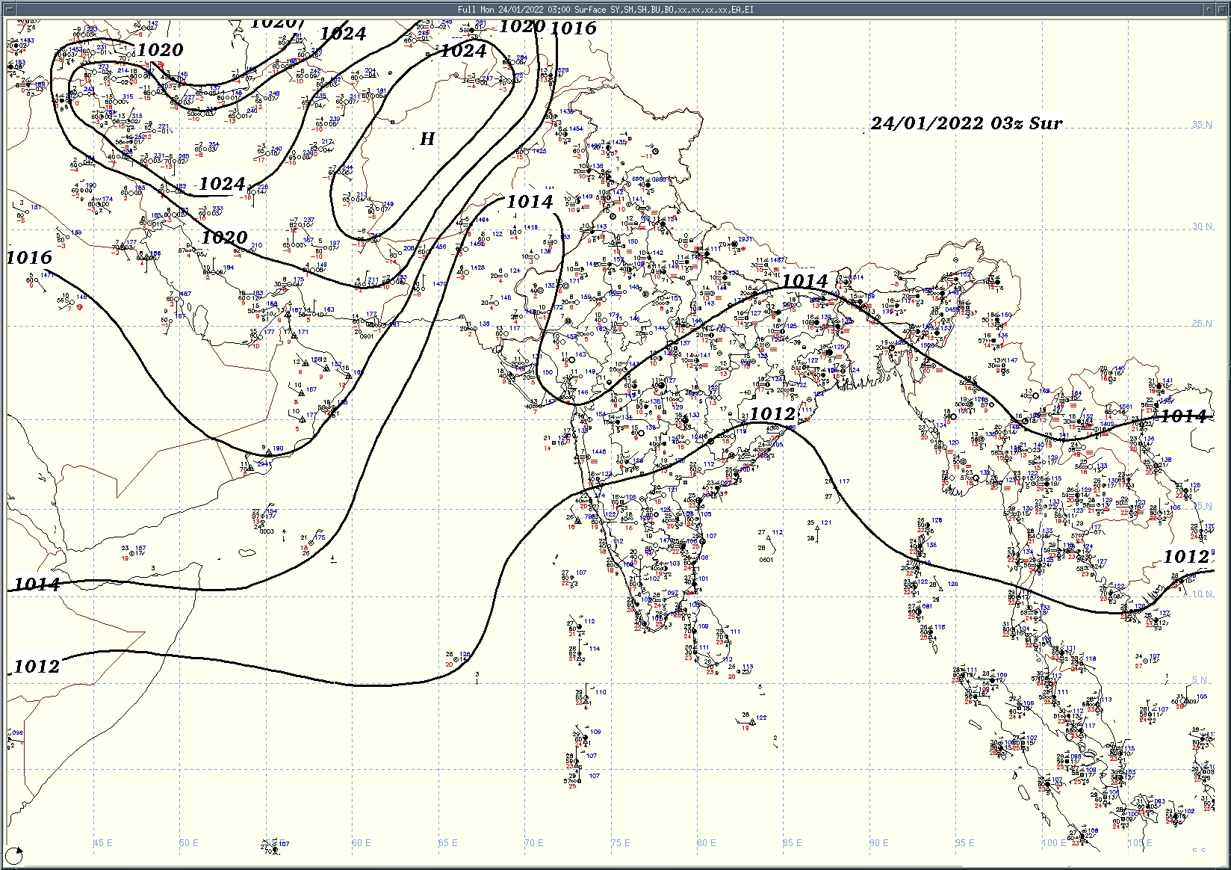  Fig.3: Analysed surface chart based on 03z observation
Dr. Anupam Kashyapi,
Scientist 'F'
Meteorological Office, Pune  Issued at 1245 hrs. IST |  | Weather Forecasting Division,  O/o The Climate Research & Services, Pune

Indian Regions | Table 1. Realised rainfall (chief amount in cm during past 24 hrs)
East | most places: Nagaland-Manipur-Mizoram-Tripura, Gangetic West Bengal and Jharkhand  many places: Odisha  a few places: Assam & Meghalaya◆ and Sub-Himalayan West Bengal & Sikkim  isolated places: Arunachal Pradesh and Bihar  Bhuban 3.7, Paradeep cwr 3.6, Panposh 3.0, Tamenglongi & Chakradharpur 2.0 each, Ghatsila 1.7, Kabi & Sherghati 1.6 each, Kharagpur( i.i.t) & D.p.ghat 1.5 each, Bodh gaya 1.3, Burdwan (pto) 1.1, Lengpui & Chandel 0.9 each, Sankalan, Chaibasa & Gaya aero 0.7 each, Daparijo 0.6, Gangtok 0.5, Basar, Chaparmukh, Kheronighat & Chauldhowaghat 0.2 each, Tawang AWS 0.1.
North | most places: Uttarakhand●/*, Himachal Pradesh●/* and Jammu-Kashmir and Ladakh●/*  many places: Punjab  a few places: east Uttar Pradesh+++ and west Uttar Pradesh+  isolated places: Haryana  dry weather: Rajasthan  Bansi tehsil 14.6, Bansi cwc 10.2, Amroha 8.5, Khadrala 7.1, Baheri 5.8, Phangota 5.3, Naina davi 5.2, Nangal 5.1, Hardwar & Kotdwar 4.2 each, Dharmsala 4.0, Chandigarh 3.8, Kalka 3.5, Mussoorie 2.8, Bareilly pbo 2.6, Badarwah 2.5, Kargil 2.3, Bahraich 2.1, Banihal 2.0, Pathankot IAF 0.9.
Central | isolated places: east Madhya Pradesh◆ and Chhattisgarh  dry weather: west Madhya Pradesh and Vidarbha  Tamnar 1.2, Kusmi 0.6, Ambikapur 0.3, Manpur 0.2.
Peninsula | isolated places: Konkan & Goa, coastal Andhra Pradesh, Rayalaseema, Tamil Nadu and coastal Karnataka  dry weather: Gujarat Region, Saurashtra & Kutch, Madhya Maharashtra, Marathwada, Telangana, interior Karnataka and Kerala  Kvk kattukuppam ARG 2.3, Chennai AP 1.8, Pallipattu 1.5, Gudivada 1.2, Masulipatnam cdr 0.5, Castle rock 0.4, Mapusa, Koyyalagudem & Nagari 0.3 each, Panjim - imd obsy & Ponda 0.1 each.
Islands | a few places: Andaman & Nicobar  dry weather: Lakshadweep  Maya bandar 0.8, Carnicobar IAF 0.5.
Table 2. Forecast / warnings (distribution of rain / thundershowers) for 5 days (valid from time of origin upto 0830 hrs IST of next day)
Sr. No. | Sub-division Name | Day 1 | Day 2 | Day 3 | Day 4 | Day 5 | Sr. No. | Sub-division Name | Day 1 | Day 2 | Day 3 | Day 4 | Day 5
 |  | 24 Jan | 25 Jan | 26 Jan | 27 Jan | 28 Jan |  |  | 24 Jan | 25 Jan | 26 Jan | 27 Jan | 28 Jan
1 | Andaman Nicobar Islands | S | I | I | I | I | 19 | west Madhya Pradesh | D- | D- | D- | D- | D-
2 | Arunachal Pradesh | F | F | F | S | I | 20 | east Madhya Pradesh | D- | D- | D- | D | D
3 | Assam-Meghalaya | S≡ | S≡ | I | I | D | 21 | Gujarat Region | D- | D- | D- | D- | D
4 | Nagaland-Manipur-Mizoram-Tripura | F≡ | S≡ | I | I | D | 22 | Saurashtra and Kutch | D- | D- | D- | D | D
5 | Sub Himalayan West Bengal/Sikkim | F | S≡ | S | I | I | 23 | Konkan and Goa | D | D | D | D | D
6 | Gangetic West Bengal | S | I≡ | D | D | D | 24 | Madhya Maharashtra | D | D- | D- | D | D
7 | Odisha | I≡ | I≡ | D≡ | D | D | 25 | Marathwada | D | D | D | D | D
8 | Jharkhand | I≡ | I | D | D | D | 26 | Vidarbha | D | D | D | D | D
9 | Bihar | I≡ | I≡ | D | D | D | 27 | Chhattisgarh | I | D | D | D | D
10 | east Uttar Pradesh | I ≡ | D≡ | D | D- | D- | 28 | coastal Andhra Pradesh and Yanam | I | I | I | I | D
11 | west Uttar Pradesh | I≡- | D≡- | D- | D- | D- | 29 | Telangana | D | D | D | D | D
12 | Uttarakhand | S- | I- | I | D | D | 30 | Rayalaseema | I | I | D | D | D
13 | Haryana, Chandigarh and Delhi | I≡ - | D≡- | D- | D- | D- | 31 | Tamil Nadu, Puducherry and Karaikal | I | I | I | I | I
14 | Punjab | I≡- | D≡- | D- | D- | D- | 32 | coastal Karnataka | D | D | D | D | D
15 | Himachal Pradesh | S | I | D | D | D | 33 | north interior Karnataka | D | D | D | D | D
16 | Jammu-Kashmir and Ladakh | S | I | D | D | D | 34 | south interior Karnataka | D | D | D | D | D
17 | west Rajasthan | D≡- | D | D- | D- | D- | 35 | Kerala and Mahe | D | D | I | I | I
18 | east Rajasthan | D≡- | D | D- | D- | D- | 36 | Lakshadweep | S | D | D | D | D

Legends: D = Dry I = Isolated S = Scattered F = Fairly widespread W = Widespread #= heavy to very heavy rain at a few places with extreamly heavy rain at isolated places +++= heavy rain at a few places with very heavy rain at isolated places ++ = heavy to very heavy rainfall + = heavy rain ●/* = rain or snow ♦ = very light rain ≡ =fog = thunderstorm with lightning =Gusty wind / strong wind / gale wind -=cold wave/cold day =Duststorm SS=ground frost = squall/Hail
Fig. 4: Districtwise warnings for five days for Maharashtra State

Pune, Lohegaon and Pashan observations at 0830 hrs. IST of Today
 | Temperature (°C) |  |  |  |  |  |  |  |  |  |  |  |  |  | Humidity (%) |  |  |  |  |  |  | Rainfall (mm)
 | Max.  past  24 hrs |  |  |  | Dep.  from  normal |  |  | Min.  past  24 hrs. |  | Dep.  from  normal |  | Dry  Bulb |  |  | At 0830 hrs. IST |  |  | Dep.  From  normal |  | At 1730  hrs. IST of y’day | Dep.  from  normal | Past  24 hrs. | Since  1st Jan. | Dep.  from  normal
PNE | 24.3 |  |  |  | -6.1 |  |  | 10.4* |  | -0.7 |  | 13.2 |  |  | 78 |  |  | -5 |  | 48 | 16 | 0.0 | 0.0 | -0.8
PSN | 24.7 |  |  |  | . |  |  | 10.8* |  | . |  | 12.8 |  |  | 82 |  |  | . |  | 55 | - | 0.0 | 0.4 | -
LHG | 24.6 |  |  |  | -5.4 |  |  | 13.5* |  | 0.5 |  | 14.7 |  |  | 64 |  |  | 4 |  | 51 | 26 | 0.0 | 0.6 | 0.2
Local (Pune and neighbourhood) forecast
Max. / Min. Temperature (°C) |  |  |  |  |  |  |  |  |  |  |  |  |  | Weather
Date  (Jan’ 22) | Pune |  | Pashan |  |  | Lohegaon |  |  | Chinchwad |  | Lavale |  | Magarpatta
24/01 | 25 / 10.4* |  | 24/ 10.8* |  |  | 24 / 13.5* |  |  | 24 / 14.6* |  | 26 / 12.7* |  | 25 / 15.6* | Partly cloudy sky. Haze in morning hours .
25/01 | 26 / 9 |  | 25 / 9 |  |  | 26 / 11 |  |  | 26 / 13 |  | 27 / 11 |  | 27 / 14 | Mainly clear sky becoming partly cloudy sky towards afternoon/evening. Haze in morning hours.
26/01 | 27 / 9 |  | 26 / 9 |  |  | 27 / 10 |  |  | 27 / 12 |  | 28 / 11 |  | 27 / 13 | Mainly clear sky. Haze in morning hours.
27/01 | 28 / 9 |  | 27 / 10 |  |  | 28 / 10 |  |  | 27 / 12 |  | 28 / 11 |  | 28 / 12 | Mainly clear sky.
28/01 | 29 / 10 |  | 27 / 10 |  |  | 28 / 11 |  |  | 28 / 13 |  | 29 / 12 |  | 29 / 13 | Mainly clear sky becoming partly cloudy sky towards afternoon/evening.
29/01 | 29 / 11 |  | 28 / 11 |  |  | 28 / 12 |  |  | 29/ 13 |  | 29 / 13 |  | 29 / 14 | Mainly clear sky .
30/01 | 29 / 12 |  | 28 / 12 |  |  | 29 / 13 |  |  | 29 / 14 |  | 29 / 13 |  | 30 / 15 | Mainly clear sky .
Mumbai (Colaba) |  |  |  |  |  |  |  |  |  |  |  |  |  |  |  | Nagpur (AP)
Date  (Jan’ 22) |  | Tmax °C |  | Tmin °C |  |  | Weather |  |  |  |  |  |  |  |  | Tmax °C | Tmin °C |  | Weather
24/01 |  | 25 |  | 15 |  |  | Partly cloudy sky . |  |  |  |  |  |  |  |  | 28 | 14 |  | Mainly clear sky
25/01 |  | 26 |  | 15 |  |  | Mainly clear sky.. |  |  |  |  |  |  |  |  | 28 | 12 |  | Mainly clear sky.
26/01 |  | 26 |  | 15 |  |  | Mainly clear sky. |  |  |  |  |  |  |  |  | 28 | 11 |  | Mainly clear sky.
27/01 |  | 28 |  | 18 |  |  | Mainly clear sky. |  |  |  |  |  |  |  |  | 27 | 10 |  | Mainly clear sky.
28/01 |  | 29 |  | 18 |  |  | Mainly clear sky. |  |  |  |  |  |  |  |  | 27 | 9 |  | Mainly clear sky.
29/01 |  | 30 |  | 20 |  |  | Mainly clear sky. |  |  |  |  |  |  |  |  | 27 | 9 |  | Mainly clear sky.
30/01 |  | 31 |  | 20 |  |  | Mainly clear sky. |  |  |  |  |  |  |  |  | 27 | 9 |  | Mainly clear sky.

Widespread (W) | 76 - 100 |  |  |  |  | - Rainfall | Very light rain | trace to 2.4
Fairly widespread (F) | 51 - 75 |  |  |  |  |  | Light rain | 2.5 to 15.5
Scattered (S) | 26 - 50 |  |  |  |  |  | Moderate rain | 15.6 to 64.4
Isolated (I) | 1 - 25 |  |  |  |  |  | Heavy rain | 64.5 to 115.5
Dry (D) | No Rain |  |  |  |  |  | Very heavy rain | 115.6 to 204.4
Probability Terms in %: |  |  |  |  |  |  | Extremely heavy rain | ≥ 204.5
unlikely | < 25 |  |  |  |  | - Snowfall | Heavy snow | 6.5 to 11.5 cms water equivalent of rain
likely | between 25, 50 |  |  |  |  |  | Very heavy snow | 11.6 to 20.4 cms water equivalent of rain
very likely | between 51, 75
most likely | >75

